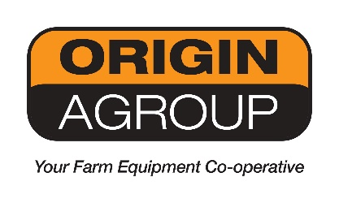

MACHINE REGISTRATION – OIL PROMOTION
*All Fields must be completed to receive your free 5Litre Vacuum pump Oil*

MODEL: ___________________________________________________________

SERIAL NUMBER*: ___________________________________________________________

COMPANY NAME: ____________________________________________________________

NAME*: ____________________________________________________________

ADDRESS*: ____________________________________________________________

____________________________________________________________

____________________________________________________________

PHONE NUMBER*: ____________________________________________________________

Please Note: Your information will only be shared between this authorised dealership and Origin Agroup (Joskin’s National Importer Distributor), by providing these details.

